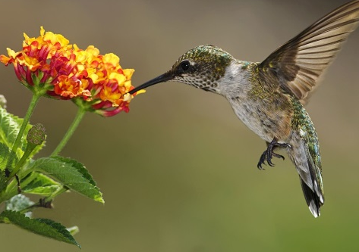
Lantana
Hummingbirds are especially attracted to bright red, purple, white, pink, orange and blue. Two favorites are bee balm and cardinal flower. However, these two plants do not have a long bloom life, so adding other nectar-bearing flowers which bloom at different times or have longer bloom periods will ensure a longer feeding season. Lantana (Lantana camara) and Trailing Lantana (Lantana montevidensis) attract all types of butterflies and hummingbirds and have a long bloom period. Lantana comes in a variety of colors including red, orange, yellow, purple or blue and white blooms. Lantanas grow well in zone 8 and higher. Nashville is zone 8a.

USDA Hardiness Zone 8a (10ºF to 15ºF)

Image sources: http://www.plantmaps.com/hardiness-zones-for-nashville-arkansas and https://www.thespruce.com/flowers-to-attract-hummingbirds-2130859

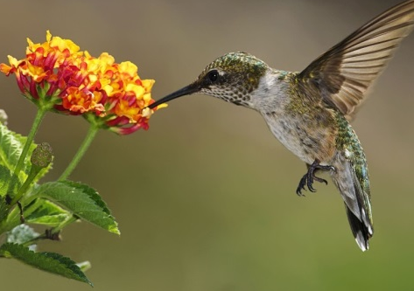
Lantana
Hummingbirds are especially attracted to bright red, purple, white, pink, orange and blue. Two favorites are bee balm and cardinal flower. However, these two plants do not have a long bloom life, so adding other nectar-bearing flowers which bloom at different times or have longer bloom periods will ensure a longer feeding season. Lantana (Lantana camara) and Trailing Lantana (Lantana montevidensis) attract all types of butterflies and hummingbirds and have a long bloom period. Lantana comes in a variety of colors including red, orange, yellow, purple or blue and white blooms. Lantanas grow well in zone 8 and higher. Nashville is zone 8a.

USDA Hardiness Zone 8a (10ºF to 15ºF)

Image sources: http://www.plantmaps.com/hardiness-zones-for-nashville-arkansas and https://www.thespruce.com/flowers-to-attract-hummingbirds-2130859

